STATEMENT BY OM RADHE

“I am the President of the Om Mandli.

The basis of Om Mandli teaching is that everyone is God, and that Om Mandli itself is God. Each inmate of Om Mandli itself is also God and such Gian is taken by every member of Om Mandli. I do not know Vedas because I have not read them. I take everyone as Braham, i.e. God. I see no difference between what I call my own and of others. I see no difference between male and female. I cannot say whether there is any agitation among the people against Om Mandli.”

Q : Do you read papers?
A : I hear no evil, talk no evil and do no evil. (Again says I read but pay no heed. But again she resiles (?) from this statement).

Q: Do you want to give a straight reply whether you read from the papers or not?
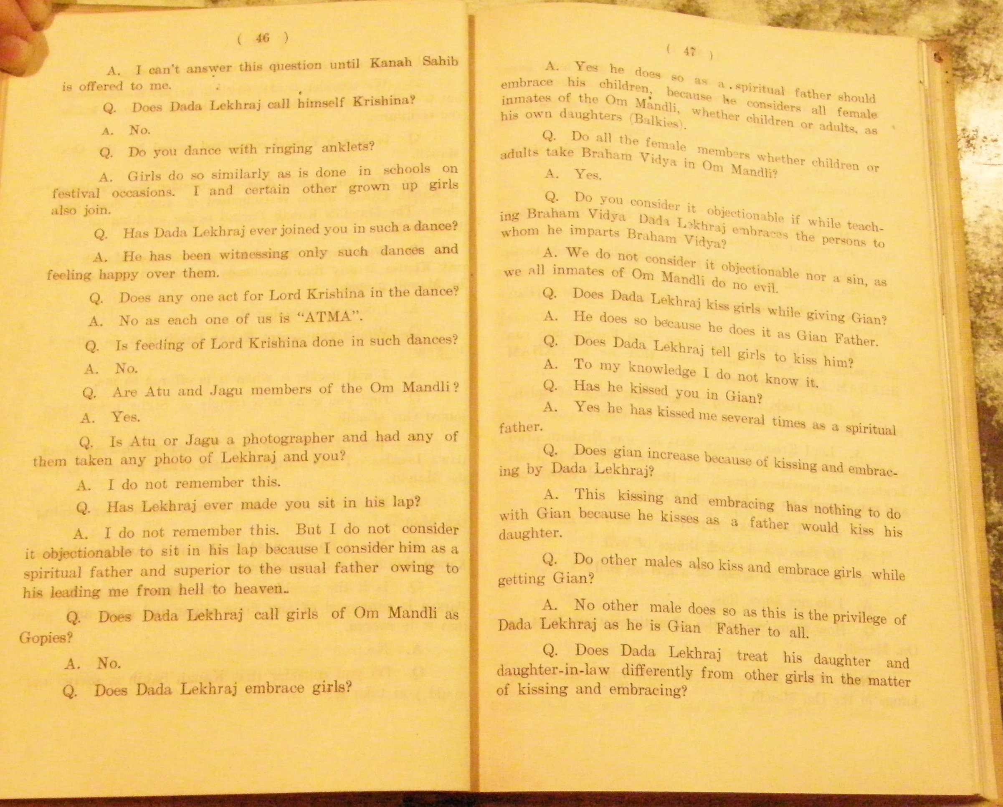
A: I do not want to give any other reply than the one I have already given

Q: Who are the members of the Om Mandli and how many?
A: Males, females and children are the members of the Om Mandli. They all number about 200. About 60 or 70 are non-residential members, and the remaining are residential. The children residential members number about 40 or 50, and residential adult females about 15 or 20 and adult males 10 or 12. The male children number about 10 or 12.

Q: Does the Mandli believe in enlisting more male or female members?
A: We are indifferent whether the members enrolled are male or female as everyone is entitled to get Gian without any restriction of caste or creed.

Q: Are Bhaibunds bearing any enmity toward Om Mandli?
A: I can’t say whether Bhaibunds are bearing any enmity as I consider everyone as Braham.

Q: Have you taken gian ?
A : I still take gian.

Q: Do you consider Lekhraj as Father?
A: We consider him as Gian Father, similarly as Christ and Krishna are considered as Father by their respective followers.

Q: What is the approximate expenditure per month of the Om Mandli?
A: I am not prepared to answer this question.

Q: How many bungalows Om Mandli has hired in Karachi?
A: 3 bungalows. One in Soldier Bazaar, and two at Clifton.

Q: Do you use antimony in the Mandli.
A: We use not only ordinary antimony but also Gian antimony which was used by Krishna and Christ, and Nanak and Mahomed also.

Q: Do you know hypnotism?
A : I do not know what is meant by hypnotism, but I know hypnotism of Gian. Every person is a magician having Gian, just as Christ and Krishna were. I know hypnotism which Christ and Krishna possessed. I picked up this Gian of Christ and Krishna in the Mandli.

Q: Do you fall in trance owing to this Gian?
A: I am in permanent trance like Prophets on account of Gian.

Q: Do you lose your consciousness on account of Gian?
A: We become conscious as well as unconscious at the same time, just as in sleep a person becomes conscious as well as unconscious. Lord Krishna has also stated that be Brahmachari while living in Grahast,( household) and also be non-eater and non-drinker by even eating and drinking.

Q: Do you observe any difference between Brahmachari and Grahasti?
A: We observe no such difference, as lotus flower though in water is also out of water.
Q: Do you believe in the institution of marriage?
A: We believe first in Gian and then in marriage, as Sita and Ram had Gian before they married.

Q: Do you believe yourself in marriage?
A: We believe marriage is mere companionship. We consider marriage between Ram and Sita as companionship marriage which is above five vices.

Q: Do you consider non-members as Gyanis?
A: I can’t say anything about non-members of Mandli.

Q: Do you permit Mandli members to marry a non-Mandli member?
A: It is left to the choice of the member concerned, but Mandli has only to give Gian.

Q: Do you prevent minor girls from going to their parents?
A: They are not prevented from going to their parents.

Q: Is your mother alive and is she a member of Om Mandli ?.
A: Yes

Q: Since how long has Om Mandli come into existence?
A: 3 to 4 years.

Om Radhe Recalled and reaffirmed.

Om Radhe: Pokardas was my father but I do not consider him so, not because my father is dead but because I take Gian from Lekhraj and also live with him as his daughter.

I have got my faith in all scriptures including Granth Sahib. In our own mandli no scripture of any religion is kept nor is any scripture read.

Oral discourses are given from Gita.

I consider paying homage to Granth Sahib as idol worship. Similarly I consider it idol worship to pay homage to any scripture, as I am ‘Aham Brahm Asmi’, (God) and the whole world is my MAYA (Creation).

I never read any scripture I consider that reading as idol worship. I consider this the Gian of Gita that I am ‘Braham’, i.e. Bhagwan, and hence I have not to bow before any scripture.

I am different from the God as conceived, for I am a living and moving God.

I cannot quote any relevant passage from the Bhagavad Gita in support of my above view, but if i look into the Gita I might find it.

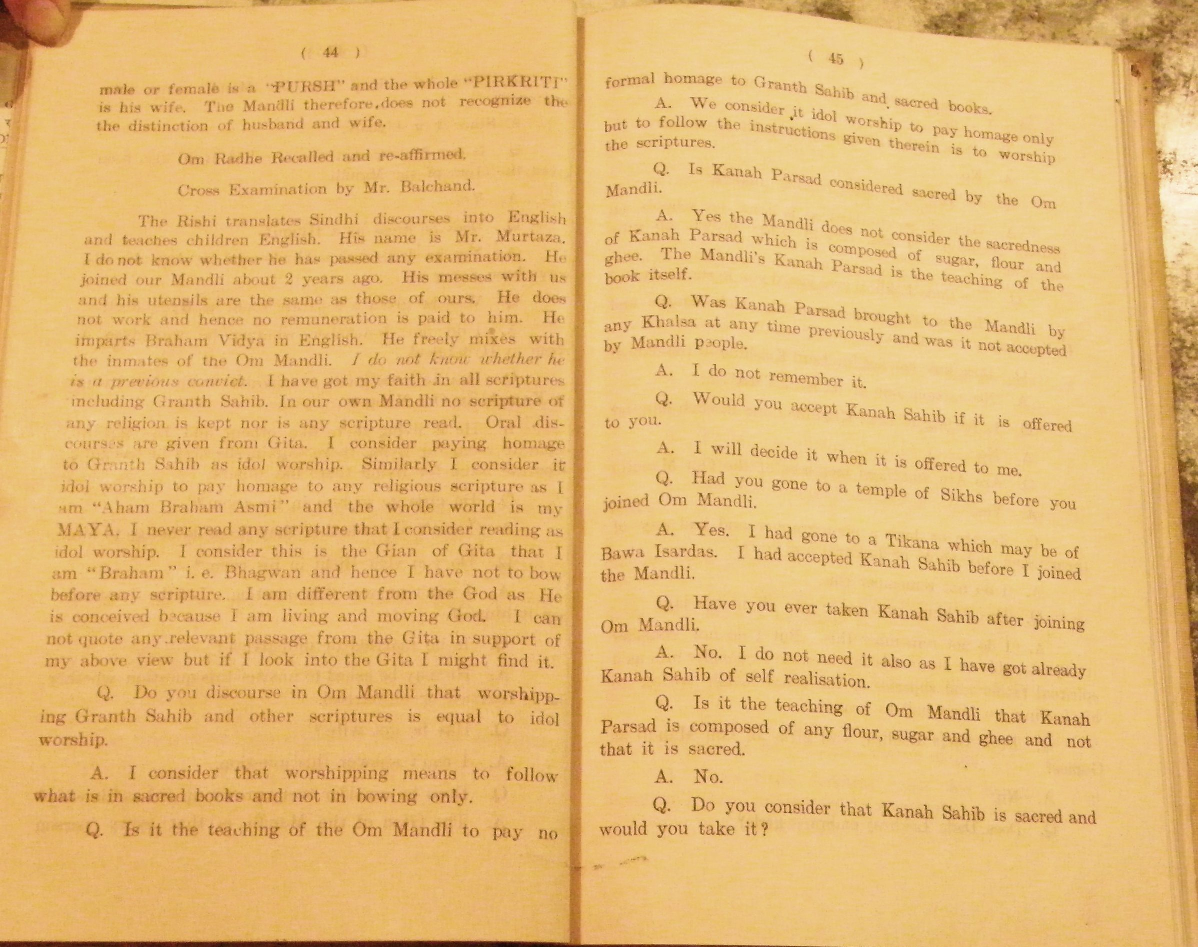
Q: Do you discourse in Om Mandli that worshipping Granth Sahib ( Sikh scripture) and other scriptures is equal to idol worship?
A: I consider that worshipping means to follow what is in sacred books and not in bowing only.

Q: Is it the teaching of the Om Mandli to pay no formal homage to Granth Sahib and sacred books?
A: We consider it idol worship to pay homage only, but to follow the instruction therein is to worship the scriptures.

Q: Had you gone to a temple of Sikhs before you joined Om Mandli?
A: Yes I had gone to a Tikarna (Sikh holy place) . I had accepted Kanah Sahib before I joined the Mandli.

Q: Have you ever taken Kanah Sahib ( Sikh toli) after joining the Mandli?
A: No I do not need it also as I have got already Kanah Sahib of self-realization.

Q; Is it the teaching of Om Mandli that it is composed of flour, sugar and ghee and that it is not sacred.
A: No.

Q: Do you consider that Kanah Prasad is sacred and would you take it?
A: I can’t answer this question until Kanah Prasad is offered to me.

Q: Does Dada Lekhraj call himself Krishna?
A: No.

Q; Do you dance with ringing anklets?
A; Girls do so similarly as is done in schools on festival occasions. I and certain other grown up girls also join.

Q: Has Dada Lekhraj also joined you in such a dance?
A: He has been witnessing only such dances and feeling happy over them.

Q: Does anyone act for Lord Krishna in the dance?
A: No as each one of us is ATMA. (God in this context)

Q; Is feeding of Lord Krishna done in such dances?
A: No

Q; Has Lekhraj ever made you sit in his lap?
A: I do not remember this. But I do not consider it objectionable to sit in his lap because I consider him as a spiritual father and superior to the usual father owing to his leading me from hell to heaven.

Q: Does Dada Lekhraj call girls of the Mandli as Gopies?
A: No.

Q: Does Dada Lekhraj embrace girls?
A: Yes he does so as a spiritual father should embrace his children, because he considers all female inmates of the Om Mandli, whether children or adults, as his own daughters.

Q:Do all the female inmates, whether children or adults, take Braham Vidya ( regarded as the core philosophy of the Vedas and Upanishads) in Om Mandli?
A: Yes

Q: Do you consider it objectionable, or a sin, while teaching Braham Vidya, that Dada Lekhraj embraces the persons to whom he imparts Braham Vidya?
A: We do not consider it objectionable nor a sin, as we all inmates of Om Mandli do no evil.

Q: Does Dada Lekhraj kiss girls while giving Gian?
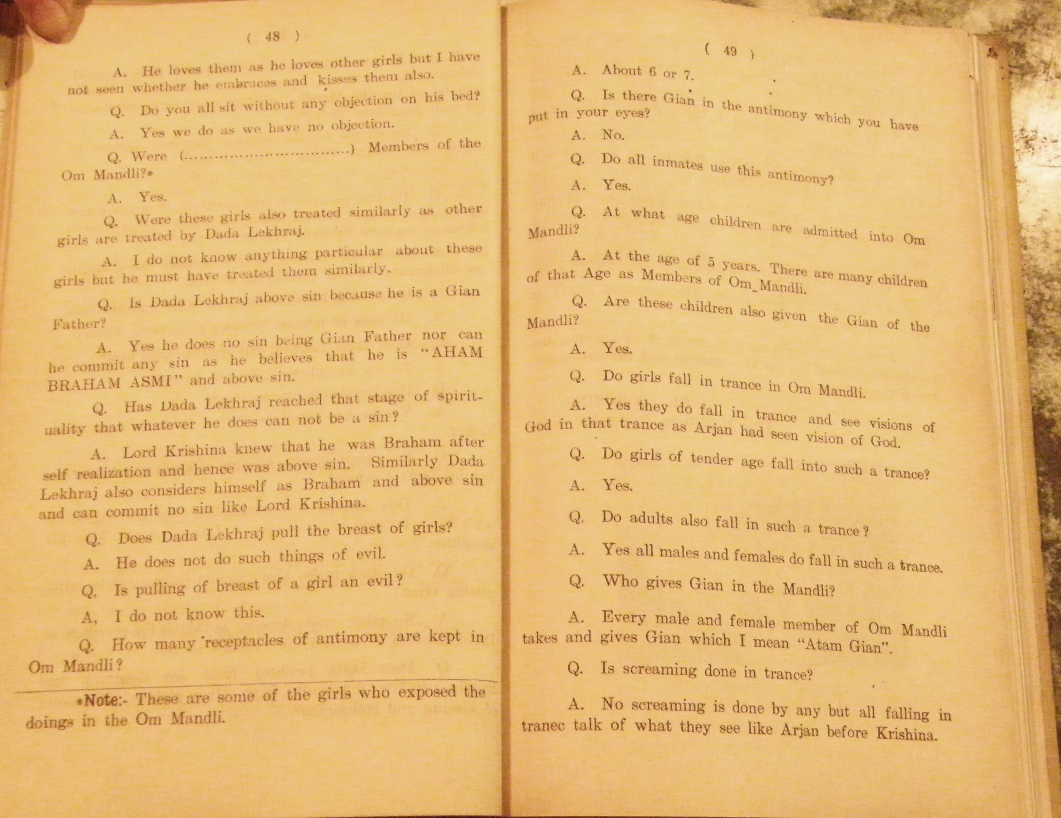
A: He does so because he does it as Gian Father.

Q: Does Dada Lekhraj tell girls to kiss him?
A: To my knowledge I do not know it.

Q: Has he kissed you in Gian?
A: Yes he has kissed me several times as a spiritual father.

Q: Does Gian increase because of kissing and embracing by Dada Lekhraj?
A: This kissing and embracing has nothing to do with Gian, because he kisses as a father would kiss his daughter.

Q: Do other males also kiss and embrace girls while getting Gian?
A: No other males do so as this is the privilege of Dada Lekhraj as he is Gian Father to all.
Q: Does Dada Lekhraj treat his daughter and daughter-in-law differently from other girls in the matter of kissing and embracing?
A: He loves them as he loves other girls but I have not seen whether he embraces and kisses them also.

Q: Do you all sit without any objection on his bed?
A:Yes we do as we have no objection.

Q: Is Dada Lekhraj above sin because he is a Gian Father?
A: Yes he does no sin being Gian Father, nor can he do any sin as he believes he is ‘Aham Brahm Asmi’ and above sin.

Q: Has Dada Lekhraj reached that stage of spirituality that whatever he does cannot be a
sin?
A: Lord Krishna knew that he was Braham after self-realization and hence was above sin. Similarly Dada Lekhraj also considers himself as Braham and above sin and can commit no sin, like Lord Krishna.

Q: How many receptacles of antimony are kept in the mandli?
A: About 6 or 7

Q: Is there any Gian in the antimony which you have put in your eyes?
A: No.

Q: Do all inmates use this antimony?
A: Yes.

Q: At what age children are admitted into Om Mandli?
A: At the age of 5 Years. There are many children of that age as members of Om Mandli.

Q: Are these children also given the Gian of the Mandli?
A: Yes.

Q: Do girls fall in trance in Om Mandli?
A: Yes they fall in trance and see visions of God in that trance, as Arjun had seen visions of God.

Q: Do girls of tender age fall into such a trance?
A:Yes

Q: Do adults also fall in such a trance?
A: Yes, all males and females do fall in such a trance?

Q: Who gives Gian in the Mandli?
A: Every male and female member of Om Mandli takes and gives Gian, which I mean ‘Atam Gian’ (Sikh: spiritual knowledge).

Q: Is screaming done in trance?
A: No screaming is done in trance by any but all falling in trance talk of what they se like Arjan before Krishna.
Q: Is a new member initiated into the Gian by girls only?
A: Yes as Miran used to give Gian. (Again says males also give Gian)

Q: Do you preach in Om Mandli that husband and wife should not believe in Grahast?
A: Yes we do preach that they should live as Sita and Ram as Lord Krishna lives in Anasakati, ie without desire.

Q: Does Lekhraj live in Grahast in Om Mandli?
A : He lives in Vanprasth.(retirement) His youngest child is about 10 years old.

Further cross examination reserved. Soon after the Mandli was banned by the government and the case withdrawn from Court.

Sd/-SOBHSING
City Magistrate
Hyderabad Sind”

